

School of Public Administration  
Bachelor of Science in Computing

**COMP491 Final Year Project  
Final Report**Academic Year 2018/19

|  |  |
| --- | --- |
| Macao Bus Travel Time Prediction Using Neural Network | |
|  |  |
| Project number: | 24 |
| Student ID: | P1507881 |
| Student Name: | Chris Zhou |
|  |  |
| Supervisor: | Benjamin |
| Assessor: | June Liu |
|  |  |
| Submission Date: | 2019.3.7 |

Declaration of Originality

I, Chris Zhou, declare that this report and the work reported herein was composed by and originated entirely from me. This report has not been submitted in any form for another degree or diploma at any university or other institute of tertiary education. Information derived from the published and unpublished work of others has been acknowledged in the text and a list of references is given in the bibliography.



2019.3.7

Abstract

In Macao, thousands of commuters travel to work or school by taking buses every day. It is known that a city like Macao is often plagued by traffic jam and huge demand in public transit, which result in bus delay and long bus waiting time. This is particularly hectic for people travelling in peak hours. In order to solve this kind of problem, this project is to develop an application allowing the users to predict the travel time required taking into account various conditions, such as the time of the day, weekend/weekday, the weather conditions (good weather, bad weather), the route and so on. After the user enter these input parameters, the application will give an output number which is the prediction travelling time. The outcome may help the users to weight different travel options and prepare beforehand.

Acknowledge

During the 4-years college life in Macao Polytechnic Institute, all of my teachers, friends and classmates help me a lot. I am very appreciated that my friends always support and comfort me when I feel stressful and negative. I feel grateful for my teachers teaching me the knowledge and offering some suggestions for my career, I would never forget all your great kind-hearted and the knowledge I learnt. I am thankful for my classmates who always stay with me during these years and help each other on study. I'm not an expressive man, but all of you will be remembered for the rest of my life. In this final year project, I have got huge amount of help and advice from my supervisor Benjamin Ng, thank you for your suggestions and support, I cannot keep this project ongoing without you.

Table of Contents

1 Introduction 8

1.1 Objectives 9

1.2 Risk Assessment 9

1.3 Summary 11

2 Background and Related Work 12

2.1 Population and public transport in Macao 12

2.2 Big Data 15

2.3 Neural Networks 16

2.4 The Main Software Tools Used 19

2.4.1 Pybrain 19

2.4.2 Scikit-learn 20

2.5 Related Work 20

3 Design Approach 22

3.1 System Structure 23

3.2 Methodology 24

4 Implementation 25

4.1 First Topic 25

4.2 Second Topic 25

5 Results and Discussion 26

6 Conclusion and Further Work 27

References 28

Appendix A. Project Management 29

Appendix B. Reflection 30

Appendix C. Program source code / UML diagram, etc 31

Table of Figures

Figure 1: Probability impact matrix before proposed solution 9

List of Tables

Table 1: Table of prioritized risk 8

# Introduction

As is known to all, Macao is the city which has the highest population density in China (Wiki, 2018) [1], and it is famous for its thriving tourism and gambling industry. Therefore, Macao attracts millions of people. For example, a great number of travellers coming to Macao for fun, thousands of gamblers coming here for make big money, and a good deal of people coming for a better job or higher salary. However, Macao is not a big city like Beijing. It has a limited range of land; narrow loads usually have one or two lanes. Thus, the arrival of so many people makes the city comparatively crowded, which causes a big trouble for the public transport and there is more and more traffic jam. Also, there are various factors which affect the public transport, such as weather and the time of the day. Hence, due to the unstable bus travelling time, people in Macao have a huge demand for something which is able to predict the bus travelling time regarding to some factors which influence transport.

To solve this kind of problem, there are various mobile application helping users to check the public transport information. Some of them only offer information of bus route, bus stop, real-time bus location and so on. However, it is not able to make any prediction. Macao Bus Traveling System [2] is a typical example. Public Transport Victoria (PTV) [3] provide users a plan maker. After choosing a start location and destination, users are able to plan the journey in very detail, and the travelling time will also show up according to the timetable. But the estimated travelling time is absolutely based on a fix timetable. 8684.cn [4] is a public transport searching system, including the travelling information of bus, train, and plane. It supports most cities in China. But it does not support public transport of Macao. Maybe the reason is that it cannot connect the database in Macao.

To cover the aforementioned shortages, this project aims to provide a comparatively perfect application for Macao people. It is to develop an application allowing the users to predict the travel time required taking into account various conditions, such as the time of the day, weekend/weekday, the weather conditions (rain, heavy rain, typhoon, etc.), the route and so on. The outcome may help the users to weight different travel options and prepare beforehand.

This project’s expected result is mainly a proof-of-concept prototype, and as such, the estimation needs not be very accurate and may be subject to modification in the future once more data is available to train the neural network [5].

## Objectives

There are two main objectives in the project. First, build a web-based application with an interface allowing users to enter the travel information and the traffic parameters (such as time, weather conditions and so on). Second, build a neural network which accepts the traffic parameters and produces an estimation of travel time including the bus waiting time. **The major requirements for this project are listed below:**

* Building a user-friendly interface
* Collecting the sample data from the application “Bus Traveling System”, then training the neural network by these sample data
* Users are able to choose a bus route, starting location and destination and the traffic parameters
* Submitting the input from user to the neural network
* Output the prediction from neural network and show it in the interface

## Risk Assessment

Table 1: Table of prioritized risk

|  |  |
| --- | --- |
| Priority | Risk Identifier and Description |
| 1 | Risk 1: The project files are disappeared and there is no backup file |
| 2 | Risk 2: The student or the supervisor has sick |
| 3 | Risk 3: The user’s web browser is not compatible with the application |
| 4 | Risk 4: The result prediction is not precise |

Note: Priority 1 is the highest risk

|  |  |  |  |  |
| --- | --- | --- | --- | --- |
| **Probability** | High |  | Risk 4 |  |
| Medium |  | Risk 3 |  |
| Low |  |  | Risk 1  Risk 2 |
|  | Low | Medium | High |
| **Impact** | | |

Figure 1: Probability impact matrix

Risk 1: The project files are disappeared and there is no backup file. The application may not work at all. It takes a long time to redo it.

Solution: Making a backup at regular intervals.

Risk 2: The project supervisor or the student doing the project may get sick one day. It’s hard to do the work when sick.

Solution: Have a few day rest to recover. It’s necessary to keep safe and keep healthy, and do the project as soon as possible when there is no sick.

Risk 3: There are so many browsers in both PC and mobile phone, the web-based application may not be compatible for all the browsers. For example, the application can work perfectly on Chrome but some content may miss or the layout is changed in Firefox.

Solution: Try three most popular browsers, see if all of them can work perfectly. If not, fix the bug as soon as possible.

Risk 4: The result prediction is not precise. But the prediction usually won’t go far from the actual bus travelling time.

Solution: Have more training to the neural network in order to make it more precise.

## Summary

This progress report is divided into 5 chapters. Chapter 1 defines the project with clear objectives. It contains the project motivation and the problem of another existing works. Besides, the risk is also discussed in this chapter. Chapter 2 states the background of this project as well as the detail related works. Chapter 3 presents the work which is already done in the first semester. Chapter 4 states the future work in next semester. And there is a conclusion in the Chapter 5.

# Background and Related Work

With the development of internet and smartphone, the use of bus travelling time prediction application is getting popular. In this chapter, the basic facts about population and public transport in Macao will be illustrated. The main technologies used in this final year project and other similar programs will be introduced below.

## Population and public transport in Macao

All the figures below are taken from the statistical database of DSEC [6] (Statistics and Census Service) in Macao.

As shown in Figure 2, the total population in Macao is steady increased by approximately 113 thousand in recent years, which is a huge amount.

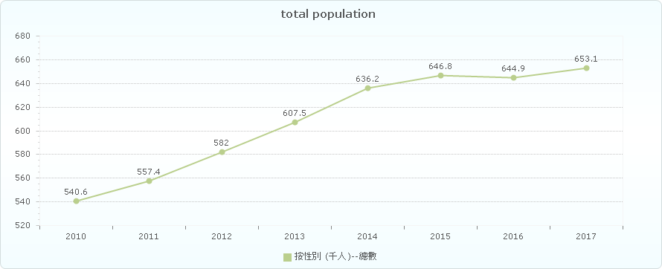

Figure 2 Total population in Macao

As seen in Figure 3, the natural population growth rate in Macao is slightly decreased recently. But even the growth rate is declined, the population of Macao is still increasing rapidly.

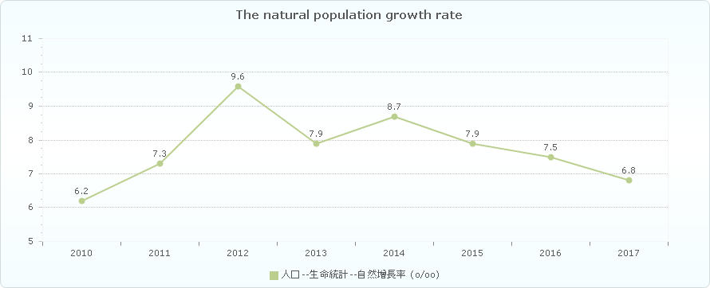

Figure 3 The natural population growth rate

Figure 4 illustrates the population intensity in Macao is always rising from 2010 to 2016. It means that the small city is getting even more crowded.

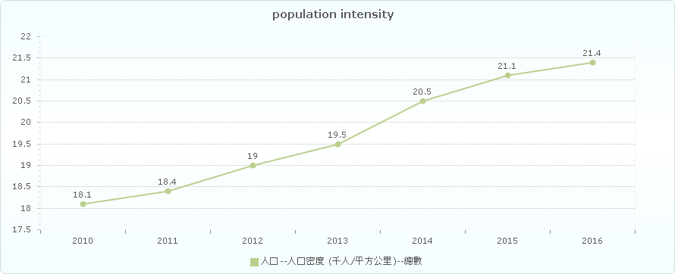

Figure 4 Population intensity

As shown in Figure 5, there are more and more motor vehicle in Macao over six years.

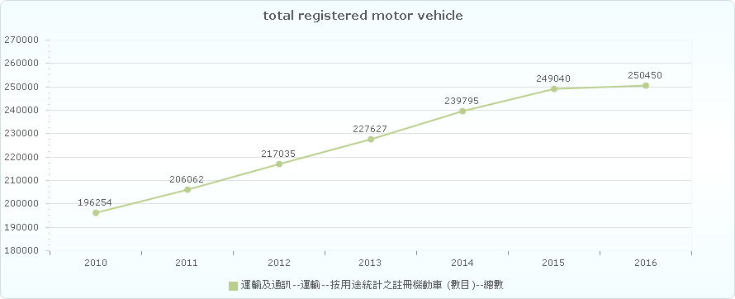

Figure 5 Total registered motor vehicle

As seen in Figure 6, the number of cars per thousand people in Macao increased steadily, which making the traffic more crowded.

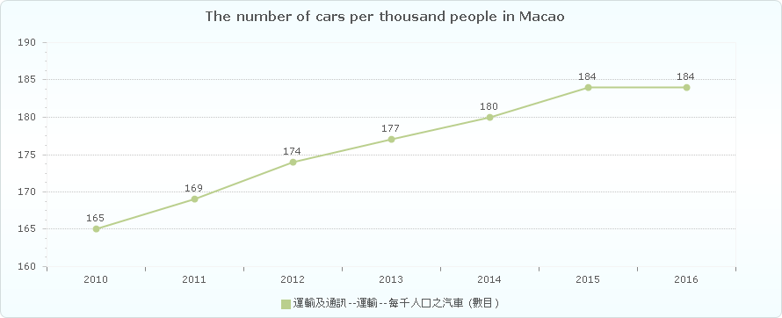

Figure 6 The number of cars per thousand people in Macao



Figure 5 Total registered motor vehicle

As seen in Figure 6, the number of cars per thousand people in Macao increased steadily, which making the traffic more crowded.



Figure 6 The number of cars per thousand people in Macao

## Big Data

Big data [7] is a word which is used to refer to dataset that are too complex or large for traditional data-processing software to sufficiently deal with. But it’s not the volume of data which matters. It is how people do with the data that is important. Big data can be analysed for discernments which may lead to better decisions and strategic business movement. Big data contains greater variety arriving in increasing volumes and with ever-higher velocity. This is known as the three Vs [8].

* Velocity. Velocity means the speed rate at when data is received or transmitting. Usually, the highest velocity of data streams directly into memory versus being written to disk. Some smart products which are able to connect internet, handle in real-time or nearly real-time. Besides it will need real-time evaluation and action.
* Variety. Variety means the various kinds of data which are available. Traditional data types were just orgranised and fit in database. With the increasing development of big data, data may have new unstructured data categories. Extra pre-processing is needed for unstructured data types need to derive meaning.
* Volume. The amount of data is important. This may be data containing unknown value, such as click number of streams of a website, Facebook data, or just a mobile app. The data might be billions of gigabytes of data, or millions of terabytes.

## Neural Networks

An Artificial Neural Network (ANN) [9] is an information processing model which is inspired by the biologic brain, for example how people’s brain manages transactions and information. The most important part of this model is the innovative architecture of the information processing system. It consists of a huge amount of interactive processing elements (which is called “neurones") working together to deal with some certain problems. ANN is similar with human, it can learn things by given sample. An ANN is set for a certain program, such as data classification or pattern recognition, by the process of learning. Learning in biology need to make adjustments to the connections which are between the nodes. This theory is also correct in ANNs.

The basic unit of computation in a neural network is the neuron [10], or called a node. The input is from an outside source or some other nodes, then calculates a result. Each input has a related weight (which is the letter “w” in Figure 7). The neuron has a function as “f “, which is defined below in the Figure 7.

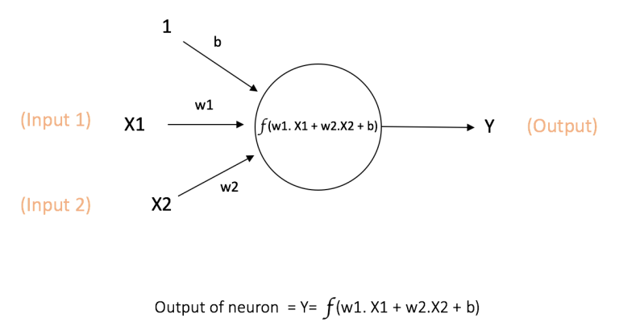

Figure 7 A node [10]

The above figure shows the inputs X1 and X2, which has its own weights w1 and w2 together with these inputs. Besides, there is additional input 1 and its weight b which is called the “Bias”.

The result Y is calculated by the function “f” which can be seen in the Figure 7. The function “f” is non-linear which is the “Activation Function”. The activation function aims at non-linearity. It matters because the most data in reality is non-linear and neurons needs to learn these non-linear representations.Every activation function takes a single number and performs a fixed mathematical operation on it. Here are some popular activation functions which are useful:

* **Sigmoid**: σ(x) = 1 / (1 + exp(−x))
* **tanh**: tanh(x) = 2σ(2x) − 1
* **ReLU**: f(x) = max(0, x)

The Figures 8 [10] below shows the activation functions above.

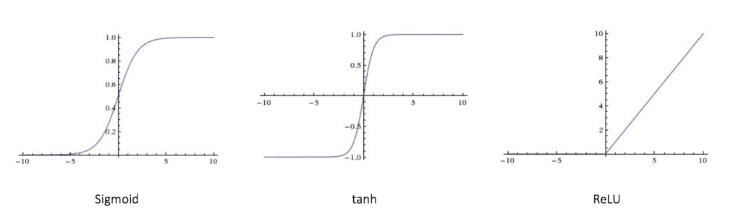

Figure 8 activation functions

As shown in figure 9, the feedforward neural network (FNN) was the easiest kind of artificial neural network (ANN). It has many nodes in each layer. The nodes in neighbour layers have connections or edges between layers. Every connection has its own weights.

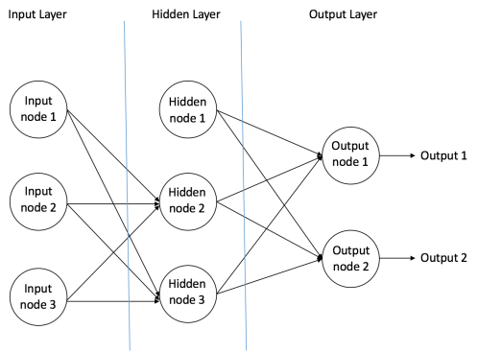

Figure 9 feedforward neural network [10]

In a feedforward network, there is only one direction which is forward, starting from the input neuron, then going through the hidden nodes and then finally to the output nodes. There are no circles or loops in feedforward network.

After building up a neural network, it needs to be trained. Backpropagation algorithm is one of the best methods to train the network. At the beginning, all the weights are assigned randomly. Taking all input in the training dataset, the ANN is available and its output can be known. This output will be compared with the ideal output which we are already aware of, and then the error is “propagated” back to the previous layer. The error is marked, and then the weights will be “adjusted” accordingly. The process is done again and again until the error of the output is below a predetermined threshold. After this Backpropagation algorithm process finishes, a “trained” neural network is done, which we believe it is good enough to work with some “new” inputs.

## The Main Software Tools Used

### Pybrain

PyBrain [11] is a modular Machine Learning Library for Python. It aims to offer flexible, easy-to-use and still stronger algorithms for Machine Learning Tasks and a variety of predefined environments to test and compare your algorithms. PyBrain is short for Python-Based Reinforcement Learning, Artificial Intelligence and Neural Network Library.

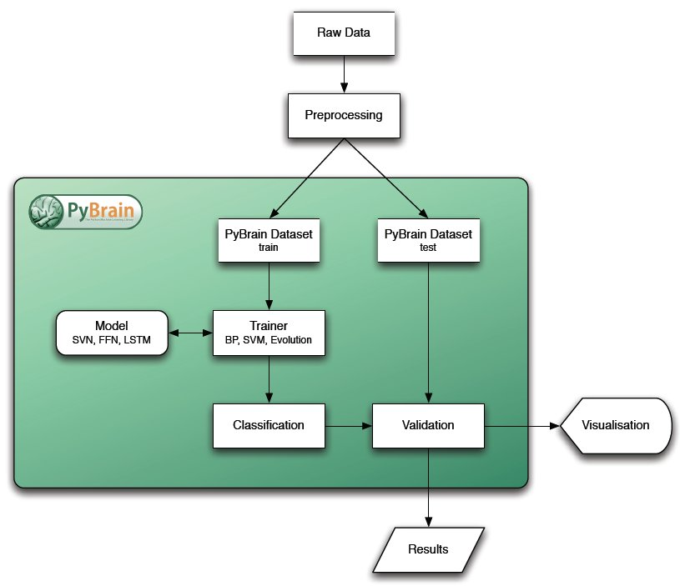

Figure 10 Pybrain's architecture

### Bootstrap

Bootstrap is a free and open-source front-end Web framework. It contains HTML and CSS-based design templates for typography, forms, buttons, navigation and other interface components, as well as optional JavaScript extensions. Unlike many earlier web frameworks, it concerns itself with front-end development only.

### Flask

Flask is a micro web framework written in Python. It is classified as a micro framework because it does not require particular tools or libraries (except for some basics standard libraries such as bottom.py. It has no database abstraction layer, form validation, or any other components where pre-existing third-party libraries provide common functions. However, Flask supports extensions that can add application features as if they were implemented in Flask itself. Extensions exist for object-relational mappers, form validation, upload handling, various open authentication technologies and several common frameworks related tools. Extensions are updated far more regularly than the core Flask program. [5] Flask is commonly used with MongoDB, which gives it more control over databases and history.

## Related Work

With the development of internet, web-based application can be accessible for both PC and mobile phone. Thus, internet programming is an important skill for this project. In order to get familiar with the neural network, the knowledge of neural network is a must. Also, programming languages such as python is needed to complete the neural network.

2.5.1 Bus Traveling System

The application “Bus Traveling System” [2] will be used in this project. It’s officially released by DSAT [13], in order to help people in Macao knowing the information about each bus. It provides information of bus route, bus stop, real-time bus location and so on. It contains huge amount of data and it is helpful for citizen in Macao. However, it cannot predict the bus travelling time regarding to the real traffic condition, and there is no input to adjust the result prediction. Therefore, the project’s expected result is able to make the bus travelling time prediction much more precise according to the real traffic condition, allowing users to input the parameters (weekday/weekend, weather and so on), and give the prediction time dynamically according to these input parameters.

2.5.2 Public Transport Victoria (PTV)

Public Transport Victoria (PTV) [3] is a statutory authority that manages train, tram and bus services in Victoria, Australia. It provides a single contact point for you to gain information on public transport services, fares, tickets and initiatives. It contains the whole Victoria’s public traffic information. After choosing a start location and destination, users are able to plan the journey in very detail, and the travelling time will also show up according to the timetable. However, the travelling time is absolutely based on a fix timetable. It cannot change dynamically regarding to the real traffic condition. Sometimes people in Victoria complain about the traffic because the buses always delay while they don’t even know when the bus is coming.

2.5.3 8684.cn

8684.cn [4] is a public transport searching system, including the travelling information of bus, train, and plane. It supports most cities in China. After users set start location and destination, the system will show the plan in detail. However, it doesn’t show the travelling time for users, only the plan and direction, due to the difficulty of connecting to all cities’ traffic database in China.

# Design Approach

After formulating a problem in previous chapters, you provide detail on how you solve the problem in the next two chapters. You should accomplish the following in Chapter 3 and Chapter 4:

* Provide sufficient information on how the project is accomplished. There should be enough detail for others to replicate your work.
* Perform detailed analysis of problem and methodical design.
* Exhibit analytical thinking. Compare alternatives in design and justify decision. Be aware of any shortcomings in design and methodology.

The required content in the two chapters depends on the nature of your project and the preferences of your supervisors. In general, Chapter 3 describes high-level ideas of the solutions, whereas Chapter 4 covers in detail how you implemented your idea, with emphasis on the key problems you have solved.

For development project, Chapter 3 is usually named “Design Approach”. You should elaborate your idea for solving the problem, with all the details of software analysis and design. In general, you should include the following:

* Requirement analysis – describe what the software system does
* Architecture – e.g. browser, mobile device, web server, app server, database server
* Use appropriate modelling tools and techniques (e.g. ER diagram, UML). Justify your design (e.g. discuss the implication and constraints, give reasons for making choice)

For research project, describe in detail how you carried out the experiments to verify your idea, and how your experimental data is obtained. The collected data should be adequate for verifying the hypothesis. You should include theoretical analysis (e.g. mathematical derivation, algorithm analysis) and well-formulate hypothesis to confirm / refute by the experiments.

This chapter is going to describe the completed work of the project. First, the system architecture of the project will be illustrated, besides the ideal user activity diagram. Then the Methodology of the project will be introduced.

## System Structure

The name of the application is *Macao Bus Predictor*. Basically, there are four components in this project. As seen in the figure 11, there are Database, Neural Network, Server and the web-based application interface. Data is collected from the mobile application “Macao Bus Travelling System”. Then it is normalized into A csv file. The neural network is made by python with PyBrain library, and it is trained by the previous dataset. The server is built for connecting the web application with neural network. Finally, the interface is going to be made to make it easier for users.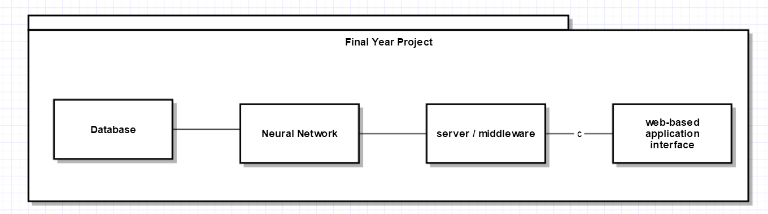

Figure 11 4 Components of the project

Figure 12 is the activity diagram, showing the basic usage of this project. Firstly, collecting data and build the neural network. Then training the neural network by this dataset. When the neural network is available, users are able to use the application, inputting the parameters and get the result prediction with the help of neural network.

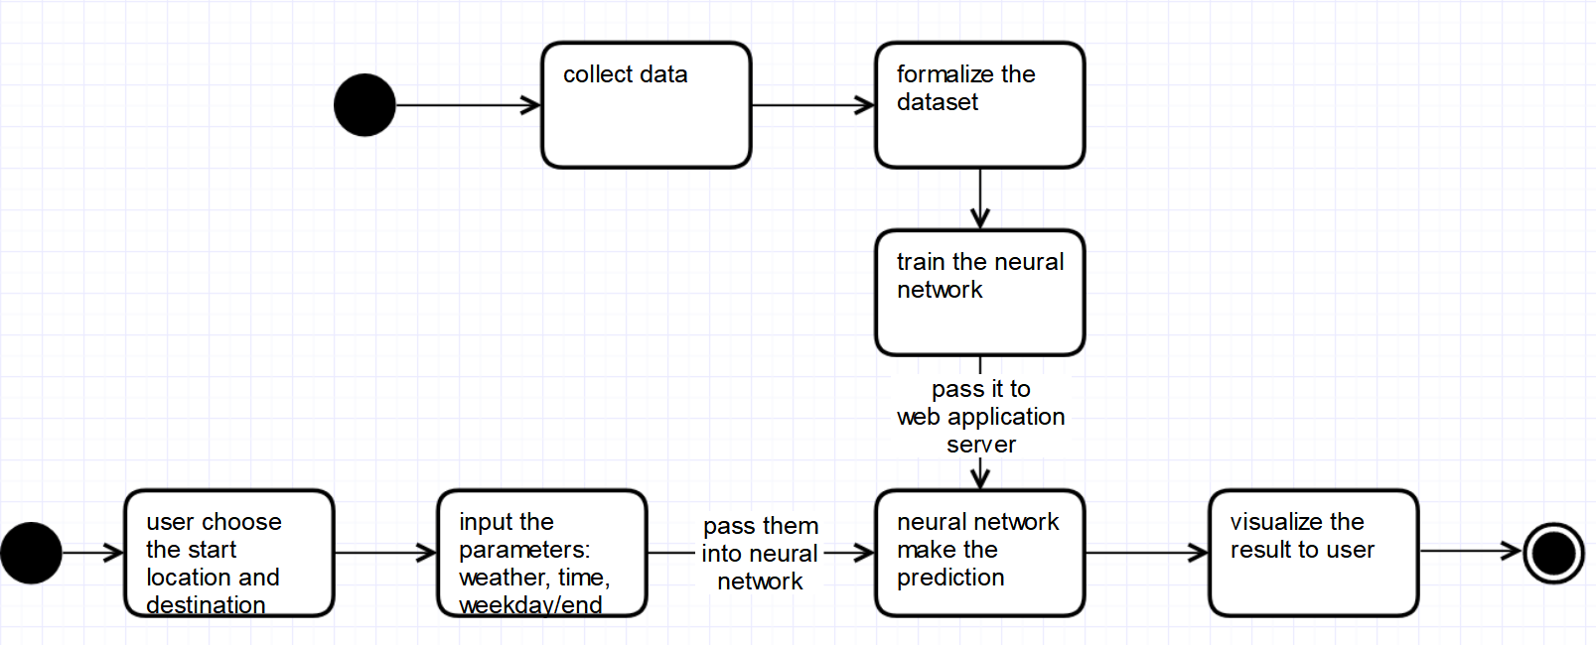

Figure 12 activity diagram

## Methodology

The methodology of *Macao Bus Predictor* website using neural networks consists of 3 major components, which are the system design of *Macao Bus Predictor*, the methodology to implement the neural networks in this project and the methodology to build the website.

3.2.1 System design

The system design of bus predictor is composed of three subsections, and they are, (1) selecting the input parameters in bus predictor, (2) predicting algorithms, (3) showing the result of prediction.

1. selecting the input parameters

The *Macao Bus Predictor* provides 2 steps and totally 6 options for users. In step 1, user needs to choose the route, start point and destination. In step 2, user is required to select three conditions such as the time of the day, the weather and weekday, weekend or holiday.

1. Predicting algorithms

The approach to determine the proposed itinerary with the users’ input parameters is the Back Propagation algorithm of neural network. The reasons and process for this selection are because neural network is fastest (relatively) technique to solve classification problem, and it is stretchable for different size of data set, well-known and is now widely used. And the BP algorithm is important to solve the nonlinear problem which is appropriate for this project’s requirement.

1. showing the result of prediction

The result will be shown in another page after user clicks the Submit button. It’s clear and easy to understand for users. Also, they can capture a screenshot if they want to memorize the result.

* + 1. Neural Networks

The methodology to implement the neural networks in this project can be composed of five subsections, which are data collection, create neural network, parameters setting and testing the performance, Store and Load.

1. Data collection

The dataset in neural network training is very important; the data set is divided into training data set and testing data set.

1. Create neural network
2. Parameters setting and testing the performance
3. Store and Load

After each training, the neural network is stored in the folder of the application, which is able to be retrained or reused directly by loading the .xml file.

* + 1. Web framework

In order to build a website which suits both computer and smartphone, a good web framework is needed. Therefore, Bootstrap is chosen to be the front-end framework and Flask is the back-end framework.

1. Bootstrap
2. Flask

# Implementation

For development project, explain how you *implement* the algorithm in a specific development platform. You may include some programming code, but show only the challenging or more interesting ones. Some cases that are worth of explaining are:

* Code pieces that are especially critical for correct system operation
* Non-standard, innovative way (algorithm, data structure) to solve a problem

Similarly, you may explain system setup and configurations that are critical for successfully implementation of your system. Other things you can include in this chapter:

* Explain choice of programming language, platforms and tools (including software toolkits or libraries)
* Unforeseen problems in implementation, and how you overcome them.

For research project, describe in detail about the implementation of the experiments/algorithms. This may include some programming code, hardware/software setup, data modelling, configuration details, choices of parameters, testing environment.

To implement this project, some development tools and library are used and they will be discussed in this chapter. In addition, the critical code and the solved solution of the key problems will be discussed. It is divided into two sections: itinerary planner and neural networks.

## Software Tools

There are some development tools and libraries used in this project implementation. The neural network is built by PyBrain which is flexible and easy to use. The website framework is developed by Flask, which is a micro web framework written in Python. Also PyBrain is a Python-based library, so it’s much easier for Flask to call the function in PyBrain’s Neural Network. Inside the website, the design and template is made by Bootstrap, which contains HTML, CSS and JavaScript extensions. It can make the website compatible with many browsers in both computer-side and mobile-side.

## Neural Network

### Creation

### Training

### Testing

## Website

# Results and Discussion

Chapter 5 provides detail of the project outcome. There is usually factual description of the software / hardware developed or experiment results. You may need to substantiate the quality of the results with software / hardware testing or statistical verification.

In addition, you have to evaluate the significance of the project outcome. First, you should discuss whether or not the project outcome meets the project objectives and provide evidence to defend your answer. You may also want to point out the contributions on a larger context, and compare your system with existing works. You can also discuss limitations. You should exhibit **critical thinking** in these discussions.

# Conclusion and Further Work

Conclude your work by stating the contributions and their significance in larger context. It should do the following.

* Summarize the main contributions of your work, and how it fulfilled the objectives. If applicable, restate the hypotheses and describing how the observed results met those expectations.
* Describe how your work may contribute to existing works in the field. How does your work fit in and support existing work in the field?
* Point out ways to extend your work, or how to overcome limitation of your work

Some questions you can try to answer as further work are as follows: Should somebody else follow up along the lines of your work, what would you recommend to do next? In other words, what would be a good topic or topics for a new project related to this work? Can your work be applied in other areas? What are the limitations?

References

[1] Wikipedia. List of cities by population density. <https://en.wikipedia.org/wiki/List_of_cities_by_population_density>. [Nov. 11, 2018].

[2] DSAT. Main page of Transport Bureau. <http://www.dsat.gov.mo/dsat/index.aspx>. [Sep. 11, 2018].

[3] Victoria Government. Main page of Public Transport Victoria. <https://www.ptv.vic.gov.au>. [Sep. 11, 2018].

[4] Guangzhou Tianqu. Main page of 8684. <http://www.8684.cn>. [Sep. 11, 2018].

[5] Wikipedia. Artificial neural network. https://en.wikipedia.org/wiki/Artificial_neural_network. [Sep. 11, 2018].

[6] DSEC. Statistics and Census Service. <https://www.dsec.gov.mo/home_zhmo.aspx>. [Nov. 11, 2018].

[7] SAS. What is big data and why it matters. https://www.sas.com/en_us/insights/big-data/what-is-big-data.html. [Nov. 11, 2018].

[8] Oracle. The Three Vs of Big Data. <https://www.oracle.com/big-data/guide/what-is-big-data.html>. [Nov. 11, 2018].

[9] Christos Stergiou and Dimitrios Siganos. Introduction to neural networks. https://www.doc.ic.ac.uk/~nd/surprise_96/journal/vol4/cs11/report.html#What is a Neural Network. [Nov. 11, 2018].

[10] Ujjwalkarn. A Quick Introduction to Neural Networks. <https://ujjwalkarn.me/2016/08/09/quick-intro-neural-networks/>. [Aug.9.2016]

[11] Tom Schaul, Justin Bayer, Daan Wierstra, Sun Yi, Martin Felder, Frank Sehnke, Thomas Rückstieß, Jürgen Schmidhuber. PyBrain. <http://pybrain.org/pages/home>. [Nov. 11, 2018].

[12] INRIA. scikit-learn, Machine Learning in Python. <https://scikit-learn.org/stable/>. [Nov. 11, 2018].

[13] Dreijer, Janto. scikit-learn. <https://scikits.appspot.com/scikit-learn>. [Nov. 11, 2018].

[14] scikit-learn developers. History of scikit-learn. <https://scikit-learn.org/stable/about.html#history>. [Nov. 11, 2018].

[15] XAMPP community. What is XAMPP? <https://www.apachefriends.org/index.html>. [Nov. 11, 2018].

[16] Apache Software Foundation. Apache Home page. <https://www.apache.org/>. [Nov. 11, 2018].

[17] The PHP Group. Home page of PHP. <http://php.net/>. [Nov. 11, 2018].

Appendix A. Project Management

Gantt chart, program plan

Appendix B. Reflection

Reflect on the progress of the yearly project. Can use first person pronoun to write.

Sample text sample text Sample text sample text Sample text sample text Sample text sample text. Sample text sample text Sample text sample text, Sample text sample text Sample text sample text.

Appendix C. Program source code / UML diagram, etc

Not compulsory